

Little Common Nursery Information Booklet
September 2026

Welcome Page 2
Meet the team Page 3
Provision Page 3
Admissions Page 4
Application Page 4
Opening hours Page 5
Early education funded hours Page 5
Additional hours Page 7
Uniform Page 8
Starting nursery Page 8
Policies Page 9
Notice period Page 9

Welcome to Our Nursery
It is my pleasure to welcome you and your child to the nursery at our successful, vibrant school — a nurturing and inspiring place where the very first steps of learning are filled with joy, curiosity, and care.
Our vision, Learning, Caring, Succeeding…together, begins right here in the nursery. We understand that starting nursery is a big milestone for both children and their families, and we are committed to making this transition a positive and enriching experience. Our dedicated team creates a warm, welcoming environment where every child feels safe, valued, and excited to explore the world around them.
At the heart of our nursery – and wider school – is a strong belief in the power of relationships. We take time to get to know each child and their family, building trust and a true sense of belonging. This foundation supports children’s confidence and independence as they begin their learning journey.
Our core values—ambitious, confident, creative, considerate, resilient, and healthy—are gently woven into everyday experiences, helping our youngest learners grow not just academically, but socially and emotionally too. Through play, exploration, and meaningful interactions, children develop the skills and attitudes that will support them throughout their time in school and beyond.
As part of our wider school community, our nursery benefits from the expertise, resources, and high standards that define our outstanding provision. Our passionate early years educators are committed to excellence, ensuring that every child receives the best possible start.
I look forward to working in partnership with you as your child begins this exciting new chapter.

Louise Moor
Headteacher

Meet our team



Mrs Moor | Mr MacGregor | Miss Crouch | Miss Ralph
Headteacher | Deputy Head | Class Teacher | SENDCo
EYFS Phase Leader
Provision and expectations
Our daily provision will be led by Hannah Crouch our qualified teacher, with a supporting team of qualified nursery practitioners. The nursery will be part of the existing successful school, providing access to additional facilities and the leadership capacity of Assistant Head for SEND Miss Charlotte Ralph and Mrs Moor, Headteacher for Little Common School.
The expectation is that all children arrive on time and stay for their full funded hours. Where this is not maintained we will work with the parent to achieve this. If funding is withdrawn due to non- attendance the place will either be paid for in full by the parent or the place withdrawn.
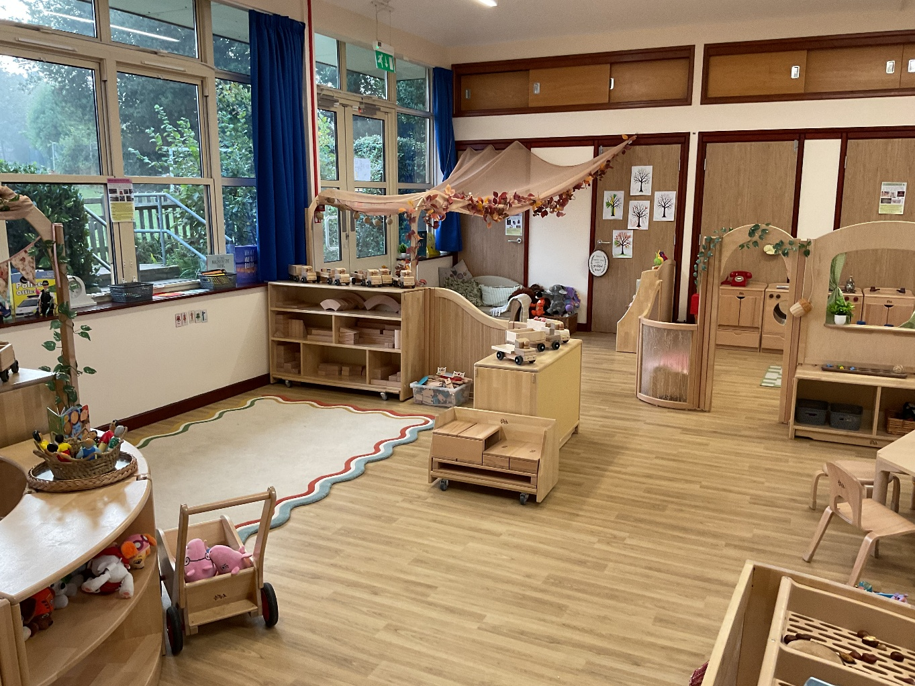

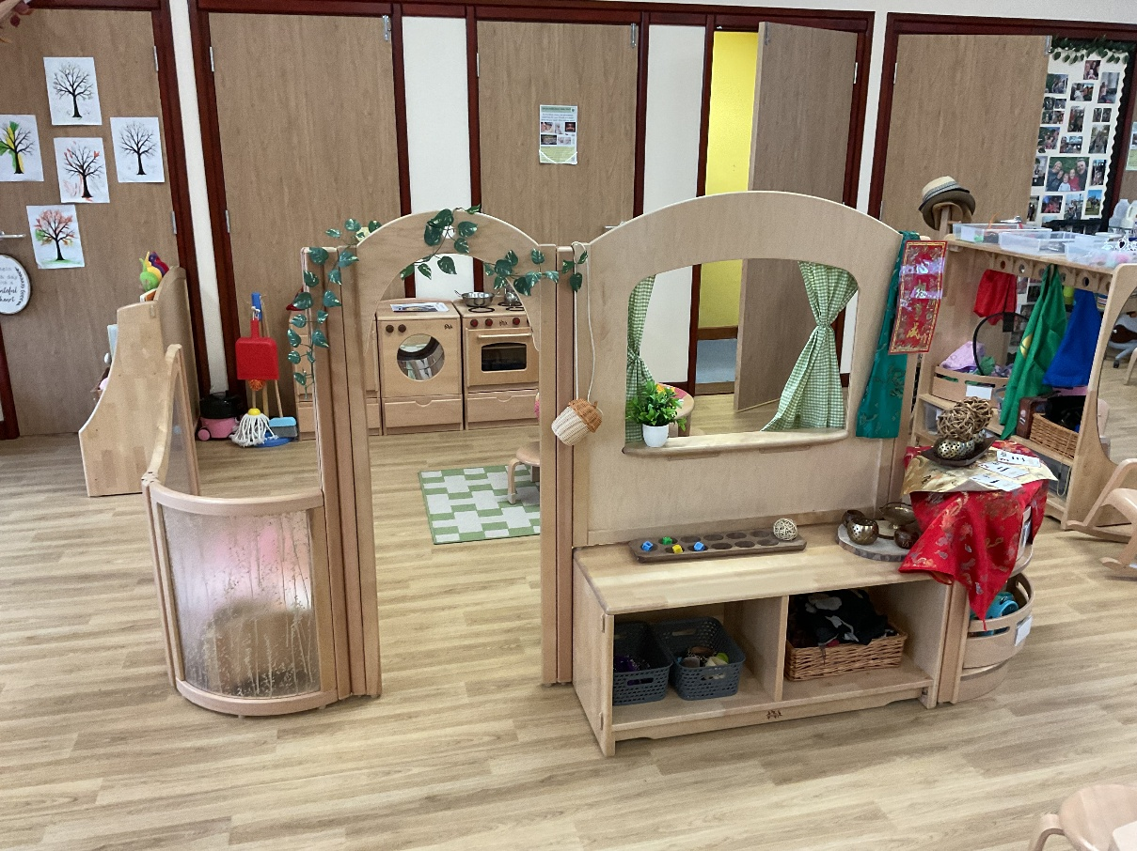

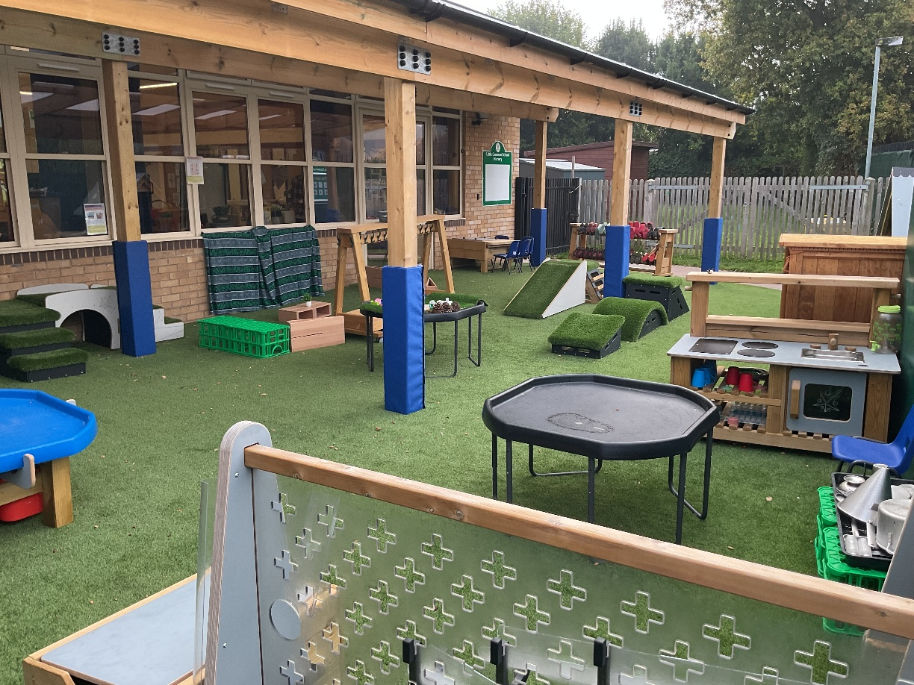

Admissions
There are no statutory requirements governing nursery admission arrangements. However, the school aims to provide places in a fair and appropriate way, always ensuring the safety and welfare of all children and the running of a viable service. The following criteria is how we will prioritise admissions along with considering each child’s needs, staffing ratios and availability of age group places at the time of admission and in the near future.
Children aged 2 – 4 years old of working parents using their full entitlement with us and requiring additional hours, spreading across 46 weeks.
Children aged 2 – 4 years old of working parents using their full entitlement with us and requiring additional hours across term time.
Children aged 2 entitled to the government funded free education and childcare hours.
Children aged 3-4 entitled to the government funded universal entitlement.

Application
In the first instance a place for our waiting list can be requested by completing the application form from our website. Our main intake is September when the older nursery children move on to school. If places become available through the year we would seek to fill these with children on the waiting list who are able to start promptly.
We will contact you when a space becomes available. Once a place has been offered a £40 deposit is required to confirm the place. For fully funded hour applications only, this will be returned to you after 6 weeks of attendance. If you are purchasing regular additional hours the deposit is held and used as credit against your final additional hours invoice. If you fail to take up your place the £40 is non-refundable.
Please note that completing an application form for the waiting list does not guarantee a place.
Opening hours and sessions
The nursery is open from 7.45am – 6pm Monday to Friday for 46 weeks of the year.

2026 – 2027 38 week (term time only) opening days
2nd September 2026 – 23rd October 2026
2nd November 2026 – 18th December 2026
4th January 2027 – 12th February 2027
22nd February 2027 – 25th March 2027
12th April 2027 – 28th May 2027
7th June 2027 – 22nd July 2027

2026 – 2027 46 week opening days less bank holidays
7th September 2026 – 23rd October 2026
2nd November 2026 – 18th December 2026
6th^{h} January 2027 – 12th February 2027
22nd February 2027 – 20th August 2027
Inset day closures are: 2 & 3 September, 4 & 5 January, 12 April
We are closed for Bank Holidays
Early education funded hours
This will be delivered through arrangement between the parent and the school subject to availability and the admission criteria set out. EYEE hours do not attract any additional charges unless you wish to purchase snacks, lunch or suncream (nappy if required).
Where the funded entitlement is for 15 hours only this will be delivered over 38 weeks during term time only.
Where the funded entitlement is for 30 hours, this can be delivered over 38 weeks during term time only or 46 opening weeks.
We will do our best to accommodate the sessions you require but this may not always be possible. We reserve the right to change sessions where there becomes an identified need for this in the best interest of children within the setting.
It is the responsibility of the parent to ensure they have applied for, received and kept up to date, their code to prove entitlement to funded hours. If this has not been achieved in time for the start date or at any time during the year, the parent must either pay for each session until funding can be achieved or relinquish the place.
See table below for applying for code dates
When parents can apply from | When you can use entitlement from
1st September to 31st December | 1st January
1st January to 31st March | 1st April
1st April to 31 August | 1st September

Link for information on receiving funded childcare
It is the parent responsibility to ensure their details of eligibility are renewed as required, in order for funding to continue. Any unfunded/additional sessions must be paid for by the parent.

 | Free education and childcare for families of 2 year olds receiving additional support (15 hours per week) over 38 weeks  15 hours from the combination below | Universal entitlement for parents of 3 & 4 year olds (15 hours) over 38 weeks  15 hours from the combination below | Working parent entitlement 2 to 4 year olds (30 hours)  This can be over 38 weeks term time or the 46 opening weeks.  30 hours from the combination below
Morning session 9am-12pm | FREE | FREE | FREE
Afternoon session 12pm – 3pm | FREE | FREE | FREE
Evening session 3pm – 6pm | FREE | FREE | FREE
Breakfast club 7.45am – 9am | FREE | FREE | FREE
Early drop off 8.30am – 9am | FREE | FREE | FREE
Late collection 3pm - 4pm | FREE | FREE | FREE
Late collection up to 6pm (snack will be provided) | FREE | FREE | FREE
Morning snack | 50p | 50p
Afternoon snack | 50p | 50p
Midday meal | £1 | £1
Suncream annual fee unlimited use | £5 | £5
Suncream daily charge when used | 50p | 50p
Nappy (not a regular service | 50p | 50p

Extra charged items will be charged regularly and need to be cleared by the end of each month.
Children must bring a water bottle and have a snack for each session. Where a snack has not been provided by the parent, a charge of 50 pence per session will apply.
Parents can choose to purchase this as a regular addition by organising with the class teacher.
Those attending both sessions on the same day will need a lunch from home (in addition to the two snacks) or a school meal can be booked for a charge of £1per day.
Meals are booked through our Arbor system with the same menu as the rest of the school.

Table of charges for additional hours and any extras purchased or required during the day whether using vouchers or fee paying.
 | 2 year olds | 3-4 year olds
Morning session 9am-12pm | £25.50 | £21.00
Afternoon session 12pm – 3pm | £25.50 | £21.00
Evening session 3pm – 6pm | £25.50 | £21.00
Breakfast club 7.45am – 9am | £10.63 | £8.75
Early drop off 8.30am – 9am | £4.25 | £3.50
Late collection 3pm - 4pm | £8.50 | £7.00
Late collection up to 6pm (snack will be provided) | £25.50 | £21.00
Morning snack | 50p | 50p
Afternoon snack | 50p | 50p
Midday meal | £1 | £1
Suncream annual fee unlimited use | £5 | £5
Suncream daily charge when used | 50p | 50p
Nappy (not a regular service | 50p | 50p

All our fees are subject to review twice per year. Decisions in April are applied on 1st September and Decisions in October are applied on 1st April each year.
We reserve the right to withdraw paid sessions where invoices are not paid promptly by 5th of each month. Example, sessions in January must be paid in full by 5th January.
Fees for additional items are charged through our information system called Arbor. Parents receive a login to Arbor when being registered for a confirmed place. The deposit is also paid using the Arbor system.
Where fees have not been paid on time and a chasing email/letter has been sent this will incur a charge of £10 which will be automatically applied to the account.
Please see our late collection policy for late collection fees where collection is beyond the booked session time.
Additional session fees can be paid using tax free childcare vouchers, all other charges for food, snack and suncream can’t be paid using childcare vouchers.
Our registration number for tax free childcare vouchers is 149894. Please send a screenshot of your payment including the child’s name, voucher code number and date to finance@littlecommon.org so we can reduce your Arbor balance accordingly.
Use this link for details

Uniform and daily needs
A dark green sweatshirt and jogging bottoms with a yellow polo shirt is available through Superstitch. This is an optional purchase. Some supermarkets sell similar clothing without our logo which can be much cheaper to purchase. Alternatively, children may wear any suitable clothing and footwear with the understanding that children undertake messy play activities and play outside.
Parents must send children with everything they will need for their day. Some things to remember are, spare clothes, nappies, wipes, nappy bags, water bottle, sun hat, coat/rain jacket, sun cream, snack & lunch (if not being purchased in school). Please make sure everything is in a named bag and any containers and water bottles are clearly named.
Link for Superstitch uniform provider

Starting nursery
Contact is made with the family when a place is identified within the setting. Main admission is each September but if places come available through the year we would seek to fill these with children on the waiting list who are able to start promptly. A verbal admission agreement is made and then followed up with an email of the agreed sessions. Class teacher will then make contact to arrange a settling in session shortly before starting nursery.
If you decline a space we can’t guarantee a space in the future, as we do not hold empty spaces and admit children subject to our criteria stated within this document.
The terms and conditions form must be signed and returned by the parent along with all joining forms the nursery requires. The school must see the child’s birth certificate when forms are returned.
Please note that we are not able to hold spaces if forms are not completed, birth certificate is not provided or deposit remains unpaid.
Settling In Session – Every child who attends Little Common Nursery must attend a ‘settling in session’ this is for one hour (minimum) scheduled with the class teacher. One parent is welcome to come into the nursery for up to 10mins on the ‘settling in session’. If the Nursery Manager feels the child would benefit from slower, staggered sessions into Little Common Nursery, then a ‘Settling in Plan’ will be created, building up the child’s hours to be able to attend their full sessions. A revised fee structure will be discussed with the parent if this takes place.
Where SEND support is identified by the parent or another professional working with the child, the SEND Co-ordinator or support officer will attend the settling in session.
Policies
Our policies can be viewed on our school website which is https://www.littlecommon.e-sussex.sch.uk/

Missed sessions
If your child is absent for any reason all paid sessions remain chargeable and must be paid for. Unpaid sessions will result in loss of place for all future additional hours.

Notice period
If you wish to cancel your nursery place this must be put in writing to finance@littlecommon.org providing 4 full weeks notice. All charges are applicable for this 4 week period and charges will apply if a child leaves during this 4 weeks notice period.

